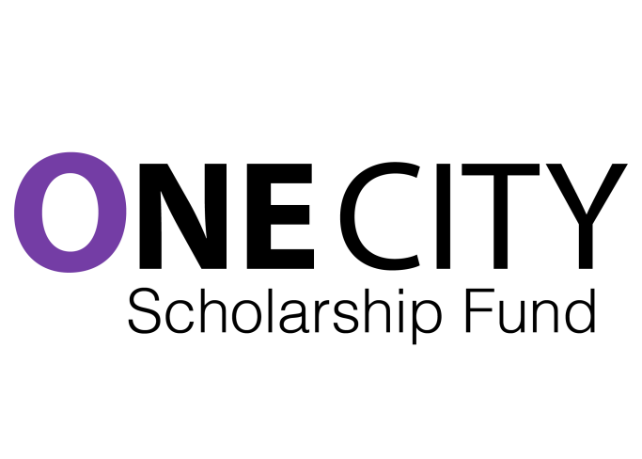
Short Email Text

I wanted to connect with you about the One City Scholarship Fund, a project I am involved in with a bunch of teachers in Toronto. I am hoping you will want to get involved as a donor and/or as a volunteer.

We have begun the process of fundraising for substantial, multi-year scholarships for students from poor backgrounds who have excelled academically, and who are graduating to attend college or university. In addition, we are building our capacity to provide supports and mentoring for these students so that they can concentrate on their studies.

By developing this scholarship we will be helping specific students, and we will be drawing attention to the fact that there are many hundreds of extremely capable and determined young people who have grown up in poverty, but want to make a real contribution to the life of our city.

One City is working in collaboration with the Toronto Foundation and the Toronto Foundation for Student Success.

The city needs these young people to flourish.

When we reach across the barriers that divide us, we become one city.

Please take a look at the attachments and our website: www.onecityfund.com, and follow us on facebook and twitter at onecityfund.

Let's talk soon.

Best,

