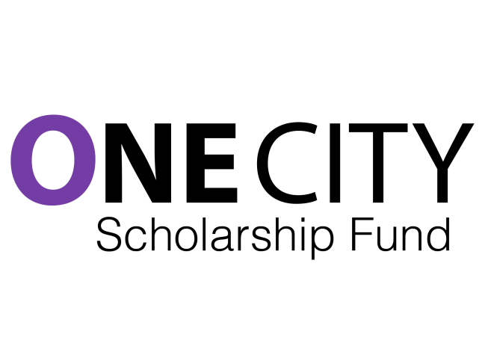
[Date]

Dear:

[Personal Intro]

I wanted to let you know about an exciting project I am involved in that may well interest you too.

I am one of a bunch of teachers who has started to develop a large multi-year scholarship for post-secondary studies (college and university) under the umbrella of the Toronto Foundation to support students from poor backgrounds who have found a way to excel. We all have had those students in our classes. This is a direct way to help these kinds of students through their next phase.

One City is teacher-driven. We are seeking 500 teachers in the TDSB who will agree to raise between $500 to $1000 from their own networks, largely by telling stories of the remarkable students they have the privilege to teach. Join us!

We want to support students as an investment in them as key players in this city's future. Our hope, as well, is that in telling these stories, we can shift the narrative about students of all levels of achievement from poor neighbourhoods to one of possibility and hope.

This is year one of a ten year project to build an endowment and a community support and mentoring network. I hope you will want to help us build towards this ambitious goal.

Check out our website too: www.onecityfund.com. Our video is viewable there, and you can read about our partnerships with the Toronto Foundation and the Toronto Foundation for Student Success. We are also on facebook and twitter: @onecityfund, and at gmail: onecityfundinfo@gmail.com

This is all quite new, quite scary and quite exciting. Let's talk!

All the best,

